Project Kit Photographs

|  |  |
| --- | --- |
| DATE | 24-Nov-2022 |
| TEAM ID | PNT2022TMID40963 |
| PROJECT NAME | IOT Based Smart Crop Protection System for Agriculture |

Generate debug message from IBM Watson IoT Platform and connect the nodes

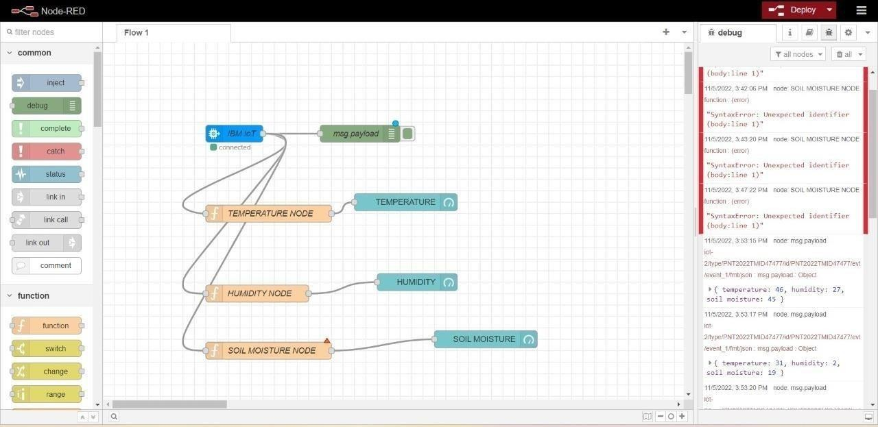

Simulated program to get the random values

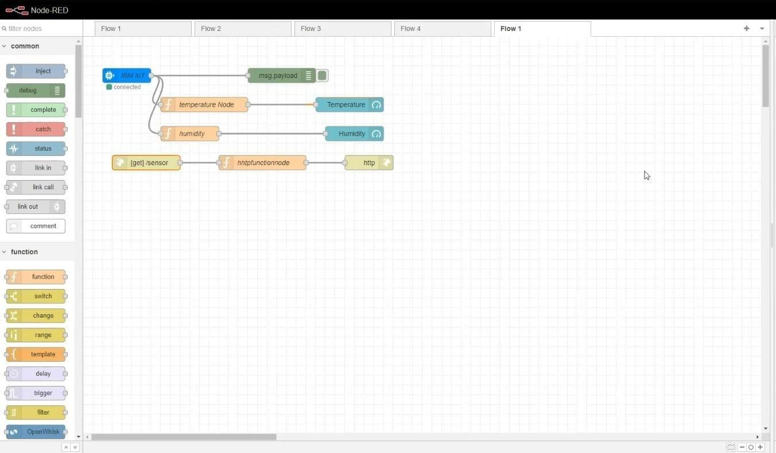

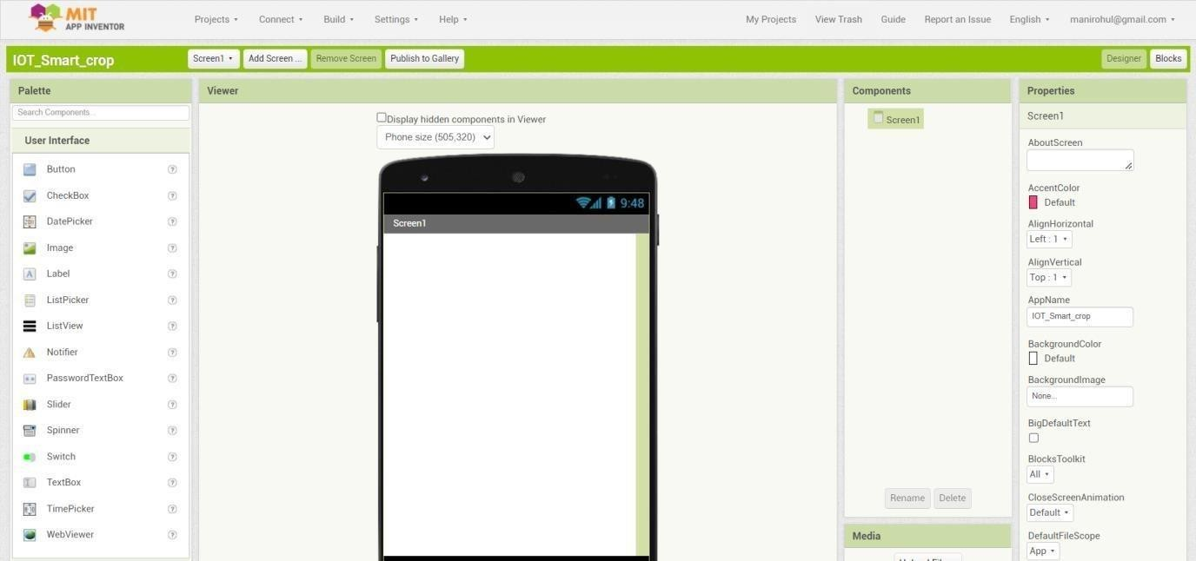MIT APP inventor to design the APP

Customize the App interface to Display the Values

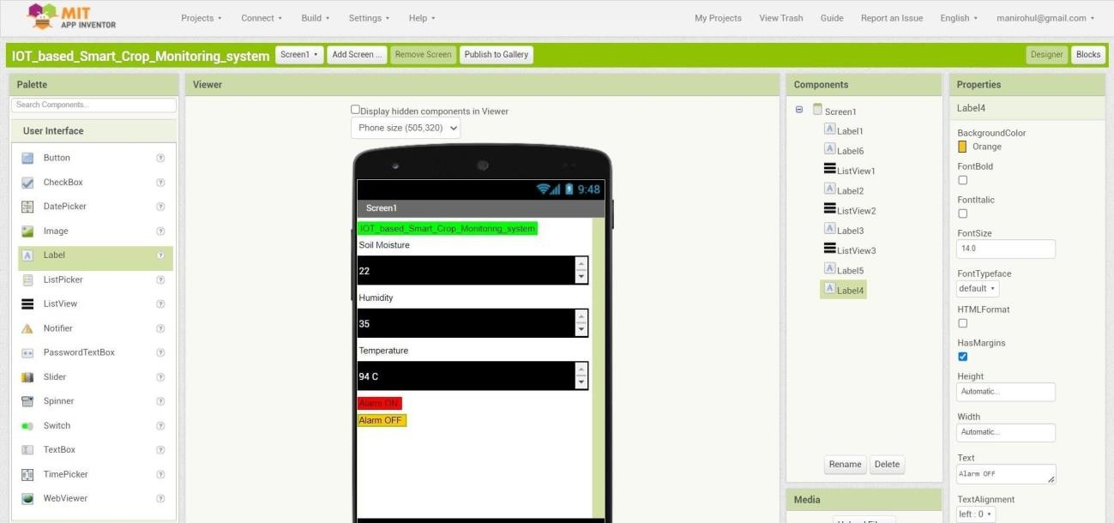

Outputs

